Assignment-No: 01

Name: Usman Jamil Abbasi

1: Use-Case Diagram:

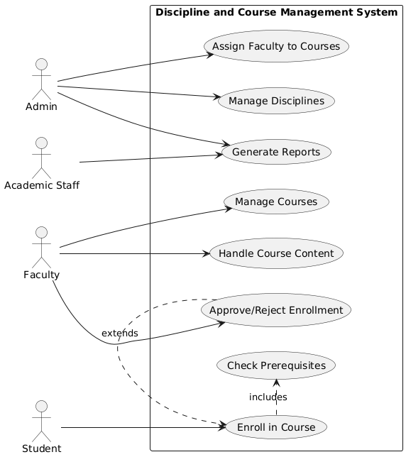

2. Fully Dressed Use Cases:

| **Field** | **Details** |
| --- | --- |
| **Use Case Name** | Enroll in Course |
| **Primary Actor** | Student |
| **Secondary Actors** | System, Faculty |
| **Preconditions** | - Student is logged in- Course exists and has available seats |
| **Main Success Scenario** | 1. Student selects desired course from catalog 2. System verifies course availability and prerequisites (UC8)3. System creates enrollment record 4. System notifies faculty of new enrollment 5. System confirms successful enrollment of student |
| **Extensions** | **3a. Prerequisites not met:**  - System displays missing requirements - Use case ends unsuccessfully**3b. Course is full:**  - System adds student to waitlist - System notifies student of waitlist position |
| **Special Requirements** | - Enrollment window must be open- Real-time seat availability check |
| **Postconditions** | - If successful: Enrollment record created- If waitlisted: Waitlist position assigned |
| **Related Use Cases** | - **Includes:** Check Prerequisites (UC8)- **Extended by:** Approve/Reject Enrollment (UC7) |
| **Frequency of Occurrence** | High (hundreds per day during registration periods) |

3. System Sequence Diagram:

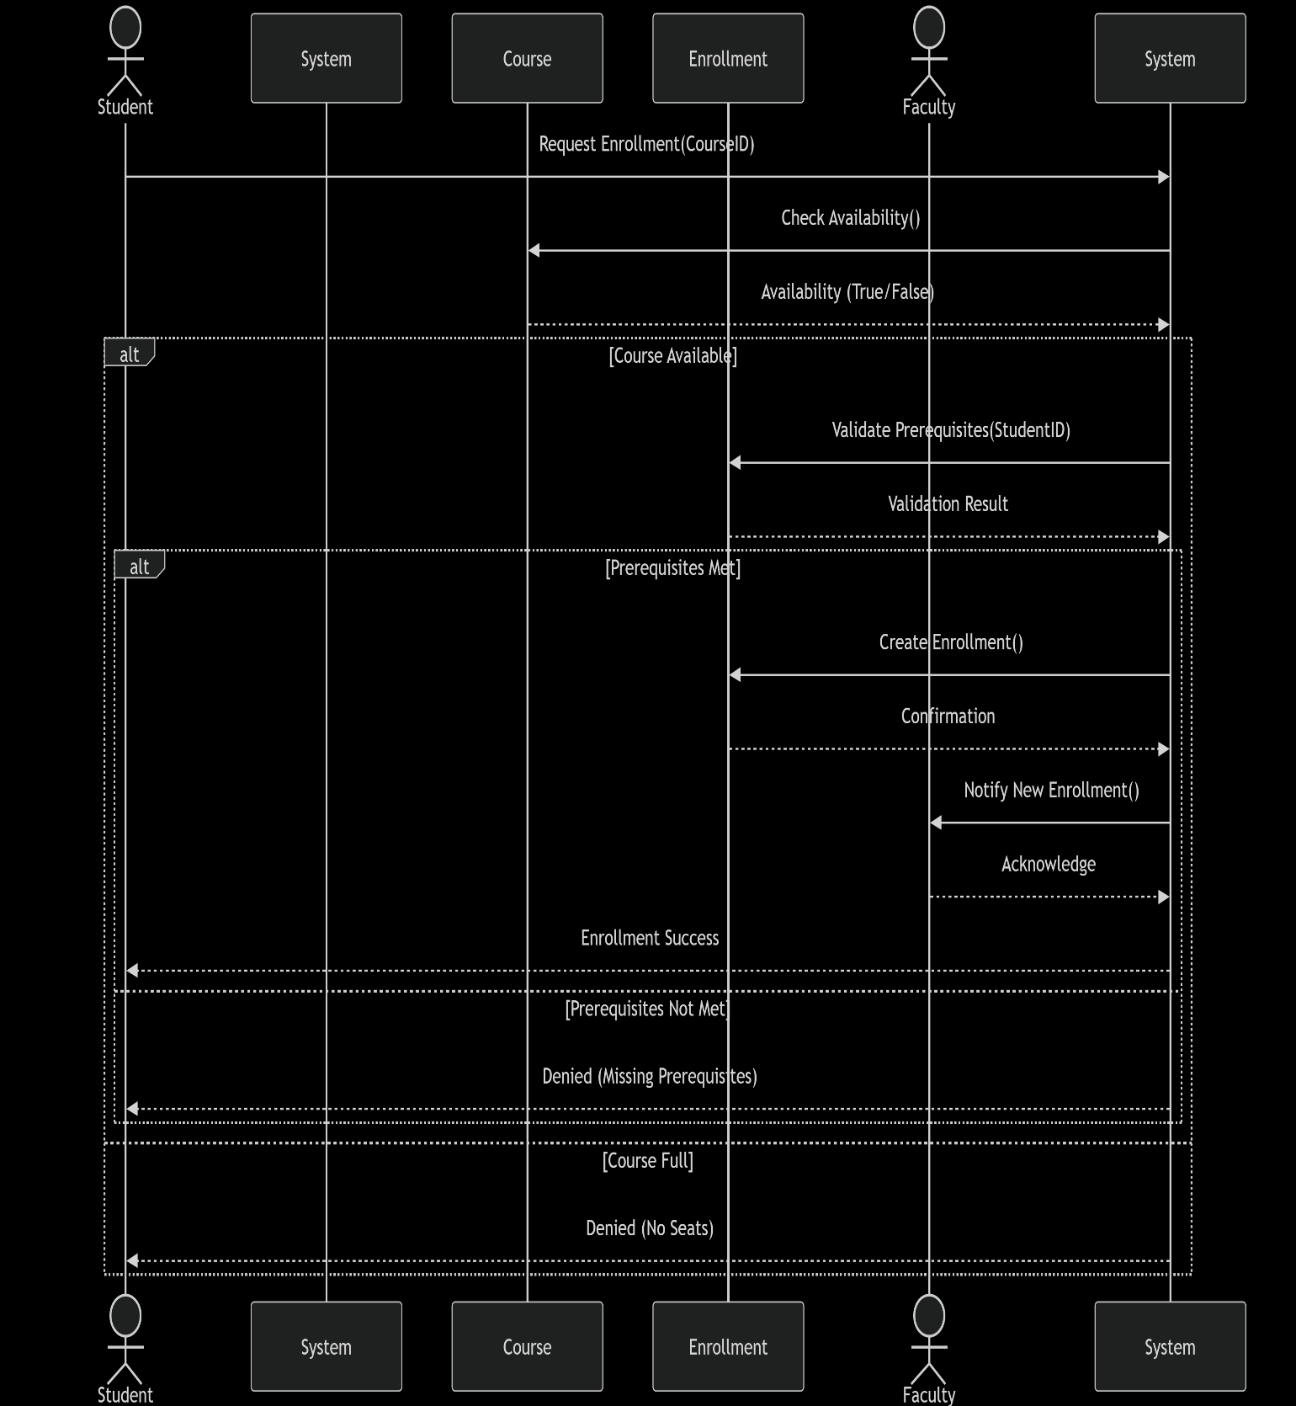

4. Class Diagram:

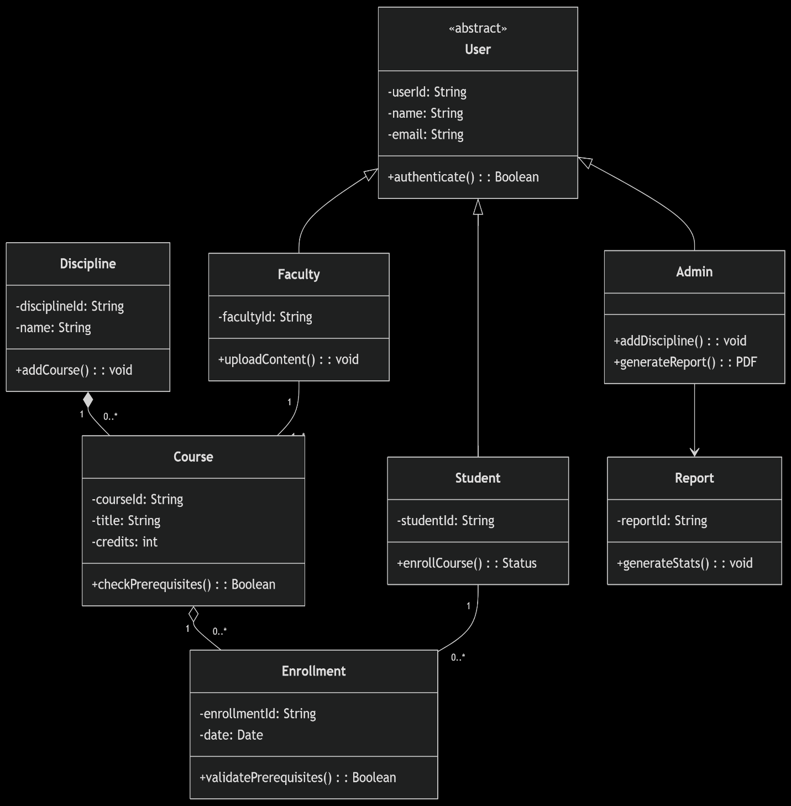

5. Package Diagram:

